**Curriculum Vitae** 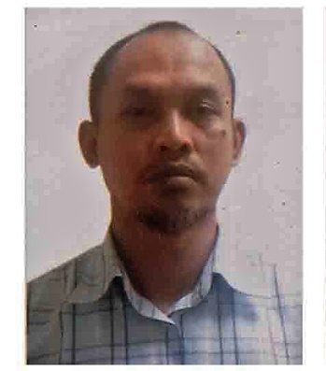

Name : Rachman Mulyadi

Contact : +97333433109

Email : m_bulenk@yahoo.com

[syaziyahdiva@gmail.com](mailto:syaziyahdiva@gmail.com)

**PERSONAL DATA**

Name : Rachman Mulyadi

Gender : Male

Date of Birth : February 10,1974

Age : 45

Address : Flat 13 Building 33 Road 0048

Block 450 Al Muqsha

Northern Governorate Kingdom Of Bahrain

Marital Status : Married with three children

Religion : Moslem

Nationality : Indonesian

Passport No. : C2612691

|  |
| --- |
| **CAREER OBJECTIVES** |

• To be connected with an established company, where my skills and abilities can be tapped and maximized effectively, preferably as position that suit to my qualifications.

• I can be sure that I could take any responsibilities that you would give to me. I am looking forward to hearing good news from you and Thank You for your best attention.

|  |
| --- |
| **JOB RESPONSIBLE** |

* Acting as store manager
* Managing and motivating a team to increase sales and ensure efficiency.
* Managing stock levels and making key decisions about stock control.
* Analyzing sales figures and forecasting future sales volumes to maximize profits.
* Initiating changes to improve the business.
* Using information technology to record sales figures, for data analysis and forward planning.
* Ensuring standards for quality, customer service and health and safety are met..
* Responding to customer complaints and comments.
* Organizing special promotions, displays and events.
* Attend MIS meeting & management meeting and always give valuable suggestion for business development.
* Sure those only high quality always making products goes to the selling area.
* Understanding forthcoming customer initiatives and monitoring what local competitors are doing.
* AS a directly to completely responsible for all the day-to-day store operation and reporting directly to the operational manager

|  |
| --- |
| **WORKING EXPERIENCE** |

Date : April 2019- Present

Company : BMMI Kingdom Of Bahrain

Address : Seef Area Kingdom Of Bahrain

Position : Assistant Store Manager Alosra Supermarket

Date : February 2014- Jun 2017

Company : GEANT HYPERMARKET DUBAI UAE

Address : IBN BATTUTA MALL  FUCOM LLC.

P.O BOX : 38323 DUBAI, UAE

Position : Head of Fresh food Department

Date : October 2011- JAN 2014

Company : Carrefour Indonesia PT Trans Retail Indonesia

Address : Lippo Supermall Karawaci Tangerang Banten

Position : Fresh Food Department Head

Date : Feb 2008- March 2011

Company : Geant Hypermarket Fu-Com International   
 Po Box 792

Address : Manama Kingdom of Bahrain

Position : Fishery Manager

Date : April 2001- April 2007

Company : Fu-Com International

Po Box 792

Address : Manama Kingdom of Bahrain

Position : Senior Supervisor fishery section

Date : April 1999- March 2001

Company : Pt Contimas Utama Indonesia

Address : Carrefour Indonesia

Position : Senior staff (Fresh Product Division) Fishery section.

Date : Jun 1998- March 1999.

Company : WAL-MART Indonesia, PT MULTIPOLAR PERKASA

Position : Receiving Staff

Date : JUNE1996- May 1998

Company : WAL-MART Indonesia, PT MULTIPOLAR PERKASA

Address : Lippo SuperMall Karawaci, Indonesia

Position : Sales floor Associate produce (Fresh Fruit and Vegetable)

|  |
| --- |
| **EDUCATIONAL ATTAINMENT** |

Elementary school : SDN Perumnas 4 Tangerang west java

1981-1987

Junior High school : SMPN 5 Tangerang west java

1987-1990

High school : SMAN 4 Tangerang, west java

1990-1993